NOORUL ISLAM COLLEGE OF ARTS & SCIENCE
KUMARACOIL



NAAN MUDHALVAN SCHEME JAVA SPRING NETWORK
College Code 312
HTML QUICK STYLER
III B.S.C. Computer science ProjectReport

Submitted by

NAVEEN KUMAR G : 23083121802111026
ABISHEK M : 23083121802111004
GANGA CHANTHNU R.K : 23083121802111012
NITHIN J A : 23083121802111028
HTML Quick-Styler
AI-Powered HTML Page Generator with IBM Granite 3.3 2B

Project Description
HTML Quick-Styler is an intelligent web page generation platform that leverages IBM's Granite 3.3 2B Instruct model to provide comprehensive HTML/CSS page creation with professional styling and responsive design. The platform addresses the challenge of rapid web development by delivering AI-powered HTML generation, automatic section detection, modern CSS styling, color palette management, and production-ready code output.
Using Granite 3.3 2B's advanced language capabilities, the system analyzes user descriptions (page title, section requirements, color preferences), generates semantic HTML structure, applies modern CSS styling with animations, creates responsive layouts, and provides multiple color palette options. The system ensures professional output through Gradio's user-friendly interface while maintaining high-quality design standards through sophisticated template generation and AI-powered content suggestions.
HTML Quick-Styler transforms web development into an intelligent, user-friendly experience through its modern Gradio interface, comprehensive feature set, and AI-powered analysis that provides personalized HTML pages considering design trends, accessibility standards, and responsive design principles.

Scenarios

Scenario 1: Portfolio Website Generation
A freelance designer wants to create a professional portfolio website quickly and efficiently. The system first detects the project requirements and analyzes the designer’s style and design preferences. Based on this understanding, it generates a complete website structure that includes a visually appealing hero section with a welcoming message and a strong call-to-action to engage visitors immediately. It also builds a responsive portfolio gallery arranged in a clean grid layout to showcase projects effectively across devices. An about section is created to present the designer’s professional bio in a compelling manner, helping visitors understand their background and expertise. To strengthen credibility, the system includes a testimonials section featuring client feedback. A contact form with proper input validation ensures smooth communication while preventing errors, and finally, a professional footer is added with social media links and essential information to complete the polished look of the website.

Scenario 2: SaaS Landing Page
A startup needs a powerful landing page for launching their new product. The system responds by creating a compelling hero banner that clearly communicates the product’s value proposition and key messaging. It then generates a features showcase section, presenting product capabilities with visually appealing icons and concise descriptions to make the benefits easy to understand. A pricing comparison table is designed with clear plan options to help potential customers make informed decisions. To build trust and credibility, the system incorporates a testimonials section that highlights positive user experiences and social proof. Prominent and strategically placed call-to-action buttons are added throughout the page to guide visitors toward signing up or purchasing, ensuring strong conversion optimization.

Scenario 3: Corporate Website
A company requires a professional corporate website with multiple structured sections. The system delivers a clean and polished layout starting with a sticky navigation header that includes company branding and allows smooth navigation across sections. It creates a company overview section that clearly communicates the organization’s mission, vision, and core values. A services grid is generated to present detailed descriptions of the company’s offerings in an organized and visually structured manner. The website also includes a team members section with photos and short profiles to add a human touch and build trust with visitors. Additionally, a contact section is implemented with company information and an inquiry form for seamless communication. The site is completed with a professional footer containing privacy policies and important links, ensuring a corporate-standard presentation.

Scenario 4: Custom Color Palette Exploration
A designer wants to experiment with different color schemes to find the perfect visual identity for their project. The system generates eight carefully curated pre-designed color palettes, including modern, vibrant, ocean, forest, sunset, luxury, creative, and minimal themes. Each palette comes with clearly defined hex color codes for every component, making implementation straightforward. The system provides a real-time preview feature, allowing the designer to instantly visualize how each color scheme affects the overall design. It ensures consistent color application across all page elements to maintain visual harmony. Additionally, dark theme–optimized backgrounds are included to support modern design trends and improve user experience in low-light viewing environments.

Architecture Overview
HTML Quick-Styler is built as a modular platform combining Python backend with IBM Granite 3.3 2B Instruct model for intelligent HTML generation. The architecture prioritizes user experience, design quality, and code production through Gradio's interactive interface and sophisticated template generation.

Core Technologies
- Python 3.x: Core programming language for application logic
- IBM Granite 3.3 2B Instruct: AI model for intelligent content generation
- Gradio: Interactive web interface framework for user interaction
- HTML5/CSS3: Modern web standards for page generation
- JavaScript: Client-side interactivity and animations
- Google Colab: Cloud-based development environment
- Responsive Design: Mobile-first approach with media queries

Pre-requisites

Software Requirements
- Python 3.8+: Download from python.org
- Google Account: Required for Google Colab access
- Gradio: Install via pip (pip install gradio)
- Web Browser: Chrome, Firefox, Safari, or Edge
- Internet Connection: Required for Colab and model access

Knowledge Prerequisites
- Python Basics: Functions, classes, dictionaries, string manipulation
- HTML/CSS: Understanding of HTML structure and CSS styling
- Gradio Framework: Basic understanding of interface components
- Web Design: Color theory, responsive design principles
- Google Colab: Familiarity with notebook interface

Hardware Requirements
- Processor: Intel i3 or equivalent (Colab runs on cloud)
- RAM: Minimum 4GB local (Colab provides GPU/TPU)
- Storage: 1GB free space for generated files
- Display: Minimum 1280x720 resolution for interface

Project Workflow

Phase 1: Environment Setup & Model Configuration
Establish Google Colab environment and configure Granite model

Activity 1.1: Set up Google Colab Environment
- Create new Google Colab notebook
- Enable GPU runtime for better performance
- Install required Python packages
- Verify environment configuration

Activity 1.2: Configure IBM Granite Model
- Access Hugging Face model repository
- Load Granite 3.3 2B Instruct model
- Test model inference capabilities
- Configure generation parameters

Activity 1.3: Install and Configure Gradio
- Install Gradio via pip
- Test basic Gradio interface
- Configure sharing options
- Verify interface rendering

Phase 2: Core Application Development
Build HTML generation engine and template system

Activity 2.1: Build Color Palette Generator
- Create ColorPaletteGenerator class
- Define 8 color palette schemes
- Implement palette selection logic
- Add color validation methods

Activity 2.2: Implement HTML Page Builder
- Create HTMLPageBuilder class
- Build section detection algorithm
- Implement template generation methods
- Create SEO meta tags generator

Activity 2.3: Develop CSS Generation Engine
- Build comprehensive CSS generator
- Implement responsive design rules
- Add animation and transition effects
- Create mobile-first media queries

Activity 2.4: Build Section Templates
- Create hero section template
- Build features grid template
- Implement portfolio gallery template
- Add contact form template
- Create pricing and testimonial templates

Phase 3: Gradio Interface Development
Create interactive user interface with multiple tabs

Activity 3.1: Interactive HTML Generation & Preview Interface
Activity 3 focuses on designing and implementing a complete HTML generation and visualization interface that enables users to create, customize, preview, and understand web page layouts through an intuitive, multi-section workflow.

Phase 4: Google Colab Deployment:
Integrate all components and perform comprehensive testing

Activity 4.1: End-to-End Integration
- Connect all interface components
- Test data flow between tabs
- Validate generation pipeline
- Test error handling

Phase 5: Deployment & Documentation
Deploy application and create comprehensive documentation

Activity 5.1: Functionality testing
- Configure Gradio sharing settings
- Enable public access link
- Test external access
- Document deployment steps

Technical Architecture
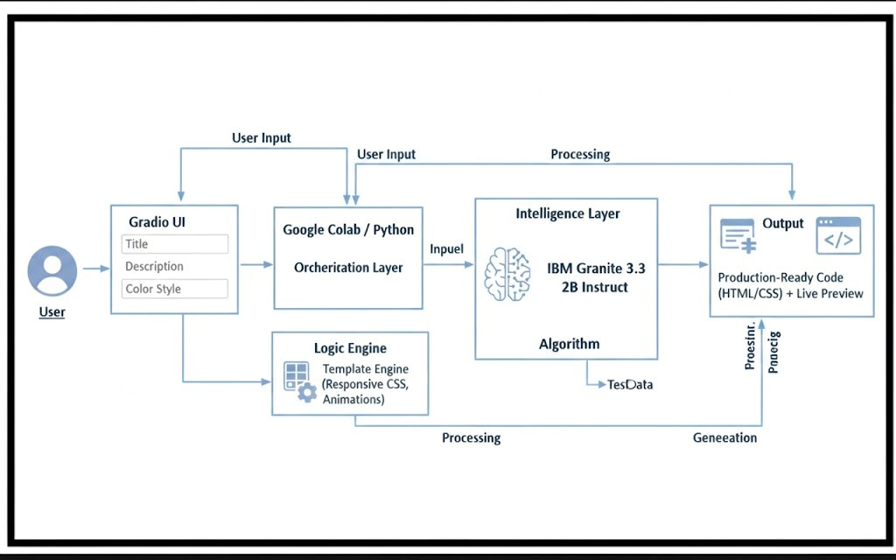

Project Structure:
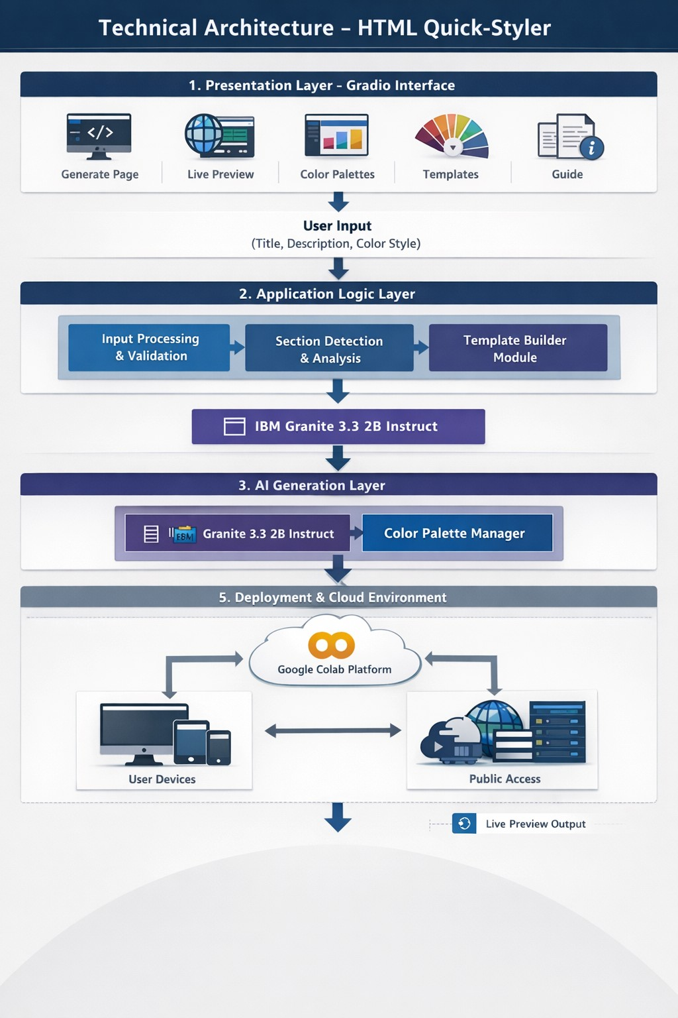

MILESTONE 1: Environment Setup & Model Configuration
Establish Google Colab environment and configure Granite model

Activity 1.1: Install Dependencies & Setup Environment
Create requirements.txt:

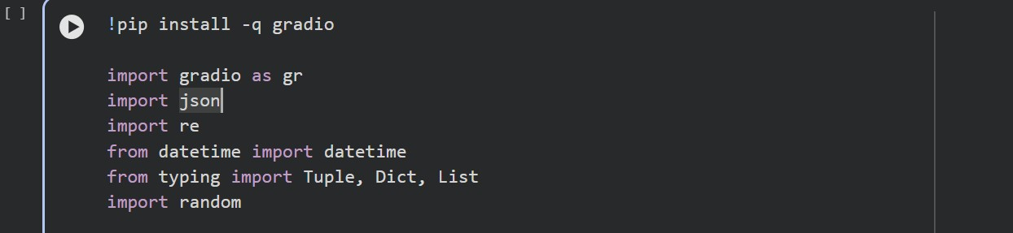
Code reference (hint: click on image and you can copy paste from Comment)

Activity 1.2: Configure IBM Granite Model
Access Hugging Face and load model:

Model: ibm-granite/granite-3.3-2b-instruct Colab Notebook:
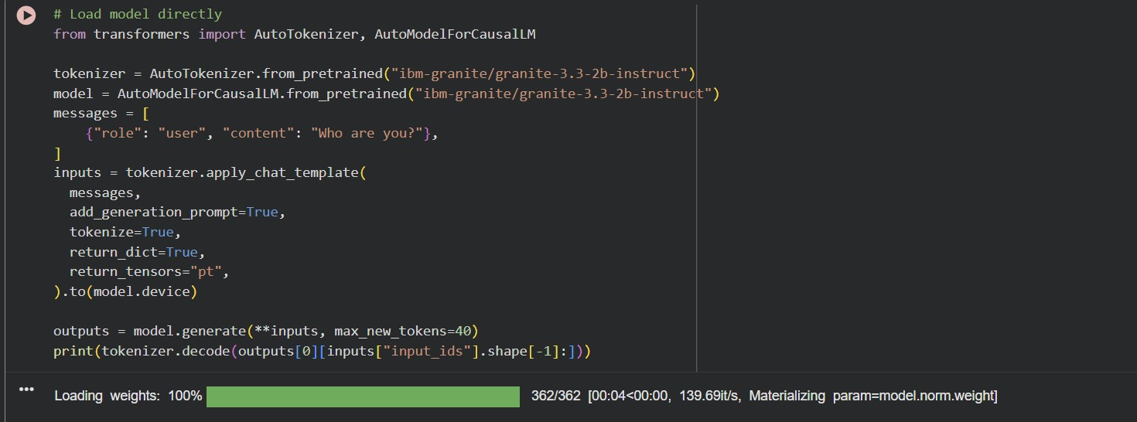
Code reference (hint: click on image and you can copy paste from Comment)

MILESTONE 2: Core Application Development

Activity 2.1: Color Palette Generator Implementation
Create ColorPaletteGenerator class with 8 predefined color schemes:

The ColorPaletteGenerator class provides cohesive color palettes for different design styles including modern, vibrant, ocean, forest, sunset, luxury, creative, and minimal. Each palette includes primary, secondary, accent, background, surface, text primary, text secondary, and border colors optimized for dark theme interfaces.
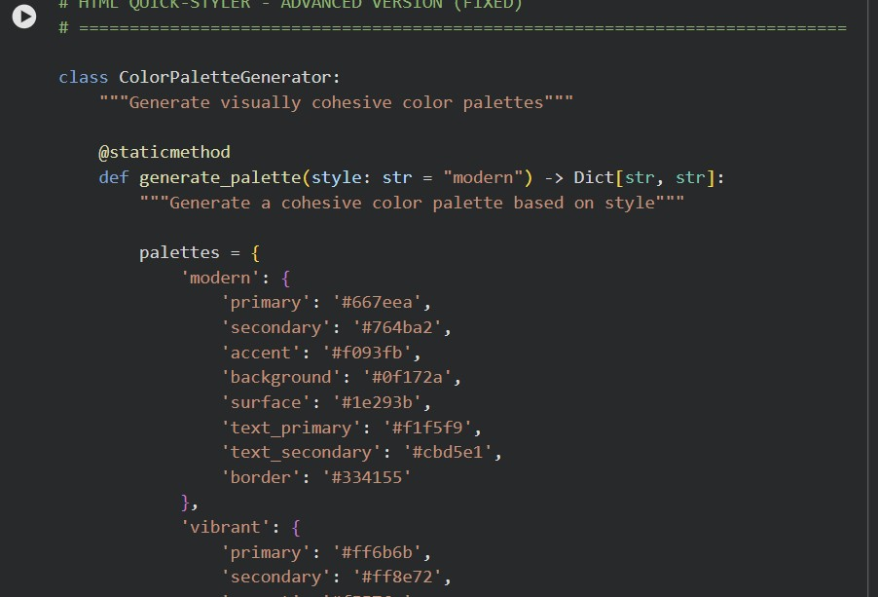
Code reference (hint: click on image and you can copy paste from Comment)
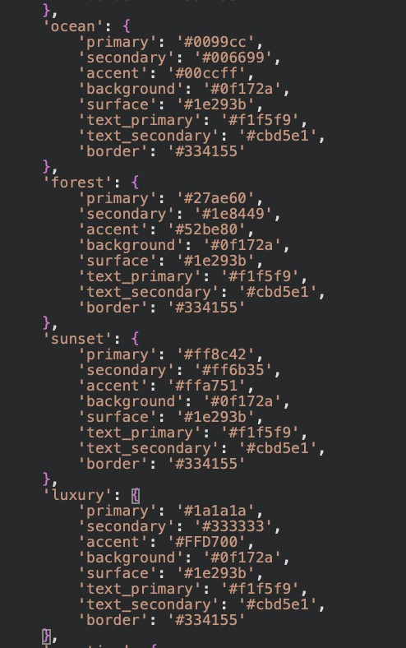
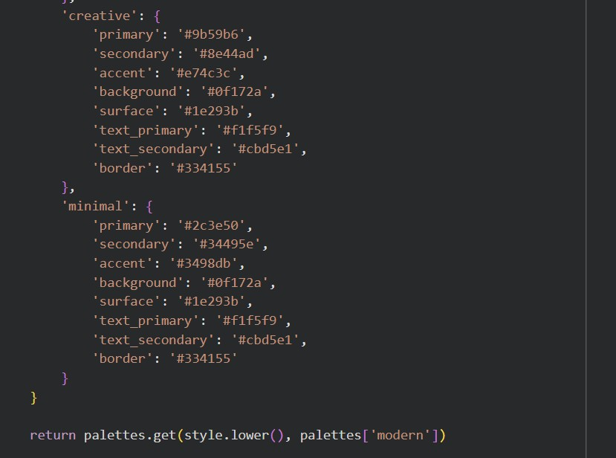
Code reference (hint: click on image and you can copy paste from Comment)

Activity 2.2: HTML Page Builder Implementation
The HTMLPageBuilder class includes:

- Section extraction from user descriptions
- Keyword detection for hero, features, about, portfolio, testimonials, pricing, contact, and footer sections
- SEO meta tags generation with Open Graph and Twitter Card support
- Individual section HTML generation with professional templates
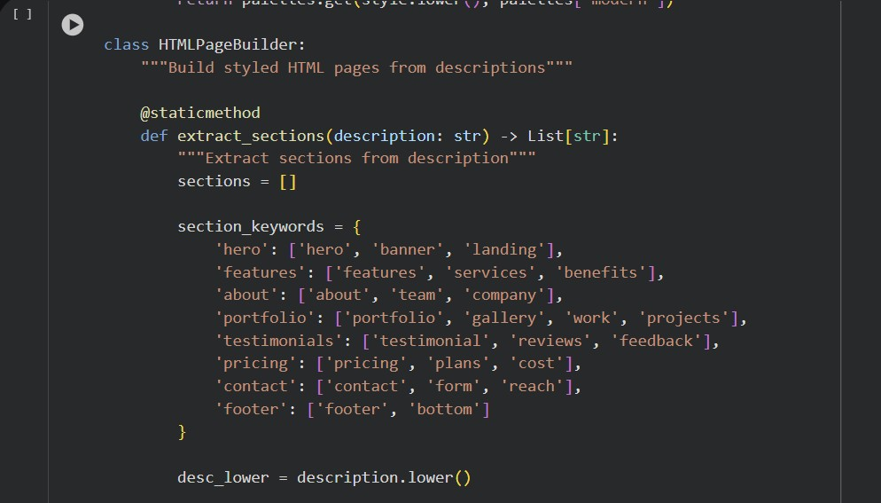
Code reference (hint: click on image and you can copy paste from Comment)

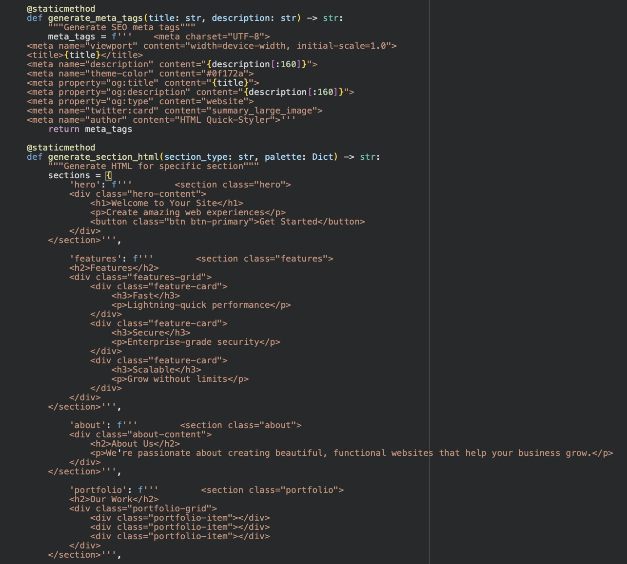
Code reference (hint: click on image and you can copy paste from Comment)
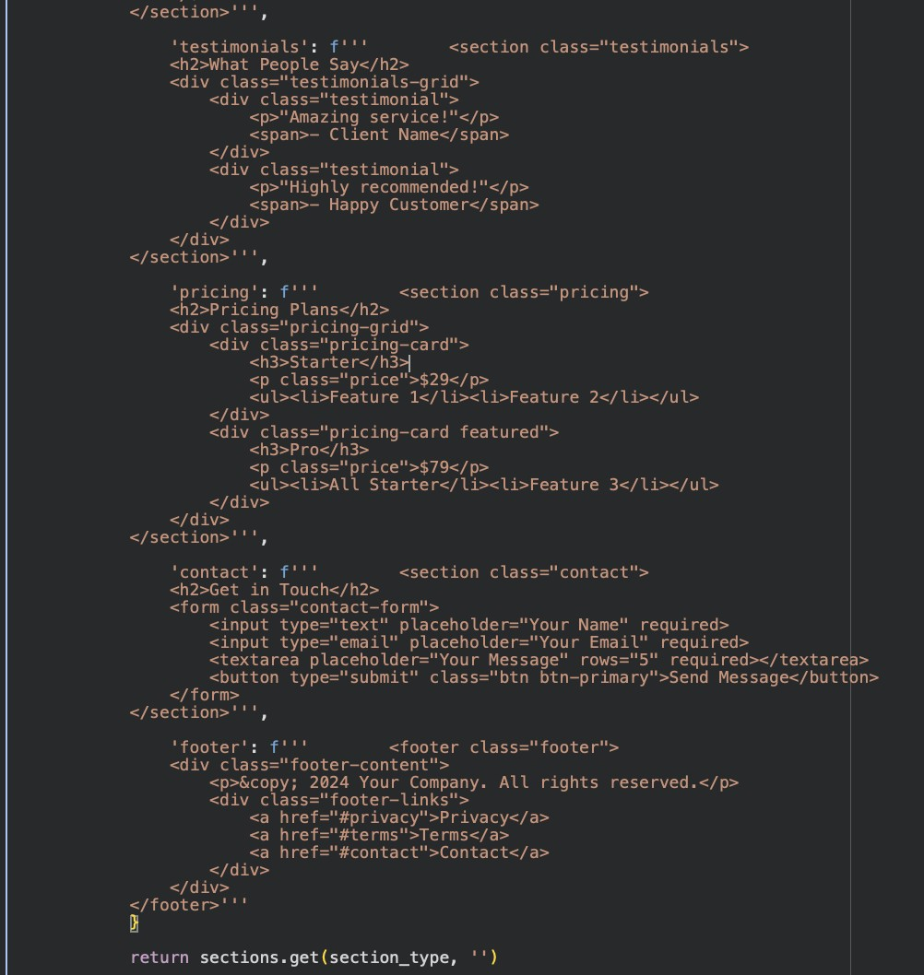
Code reference (hint: click on image and you can copy paste from Comment)

Activity 2.3: CSS Generation Engine
The CSS generator creates comprehensive styling including:

- CSS variables for dynamic color management
- Gradient backgrounds and modern animations
- Responsive grid layouts with Flexbox and CSS Grid
- Smooth transitions and hover effects
- Mobile-first media queries for tablets and phones
- Sticky header with backdrop blur effect
- Card-based components with depth and shadows
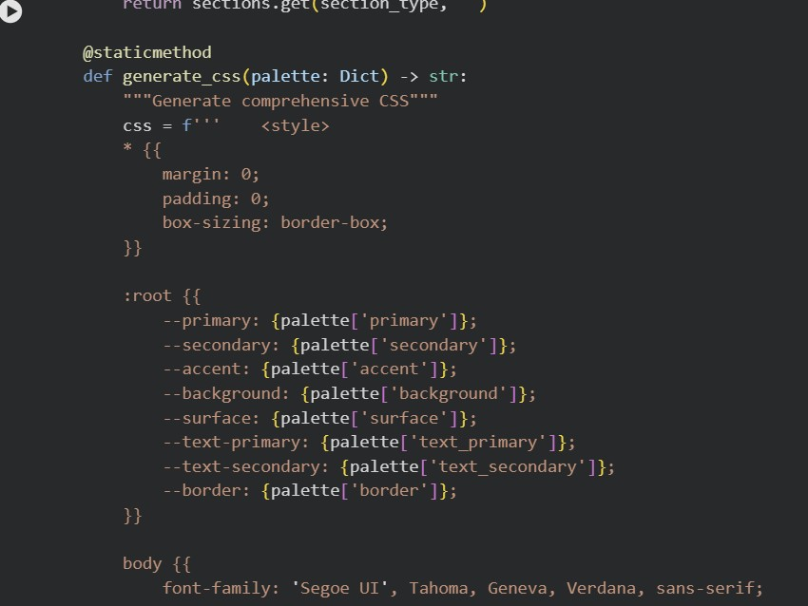
Code reference (hint: click on image and you can copy paste from Comment)

MILESTONE 3: Gradio Interface Development

Activity 3.1: Main Interface with Multiple Tabs
The Gradio interface includes 5 tabs:
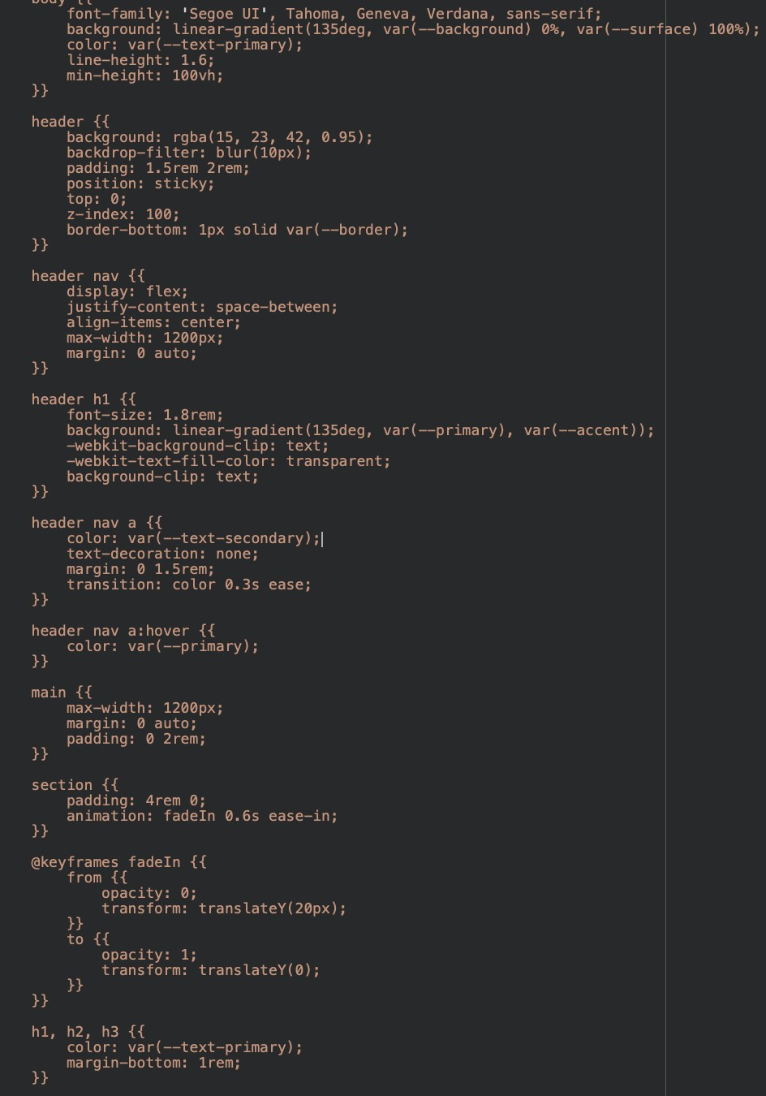
Code reference (hint: click on image and you can copy paste from Comment)
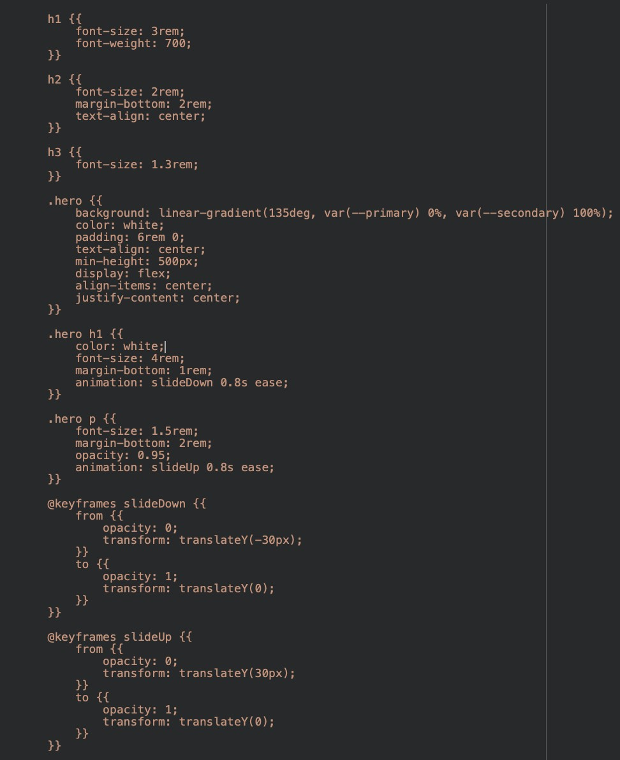
Code reference (hint: click on image and you can copy paste from Comment)
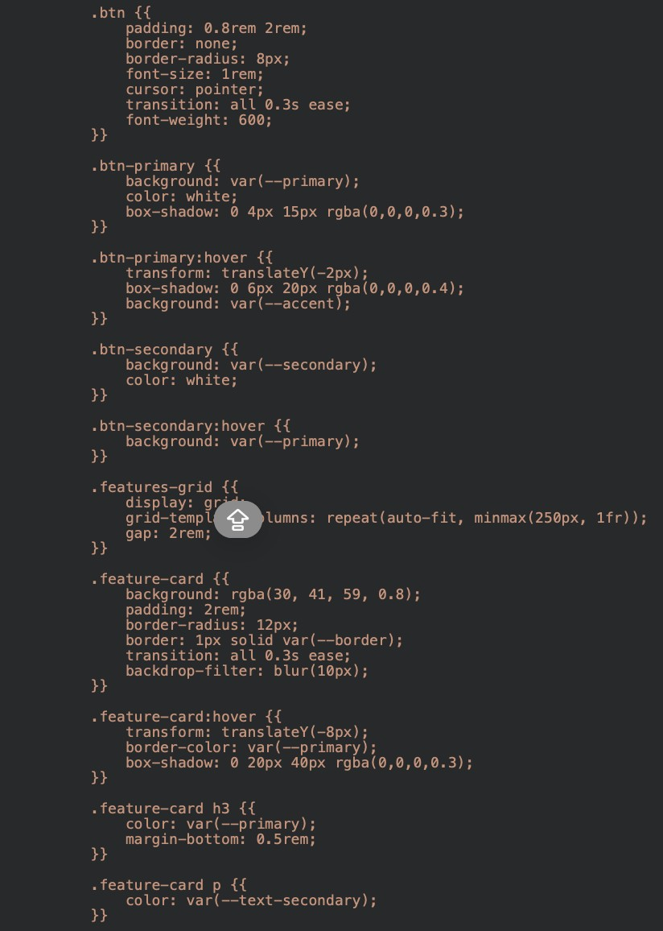
Code reference (hint: click on image and you can copy paste from Comment)
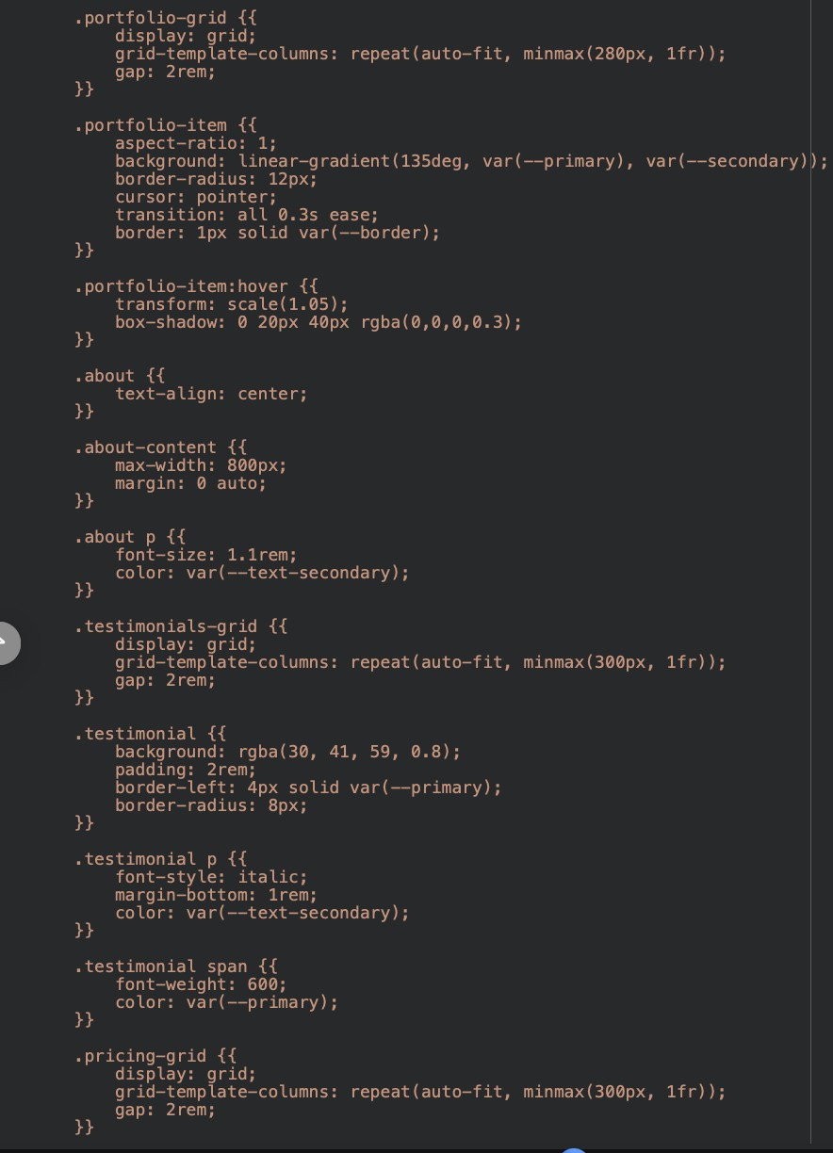
Code reference (hint: click on image and you can copy paste from Comment)
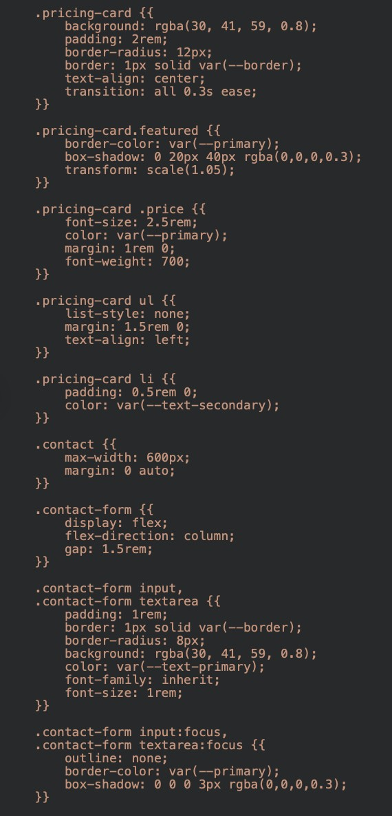
Code reference (hint: click on image and you can copy paste from Comment)
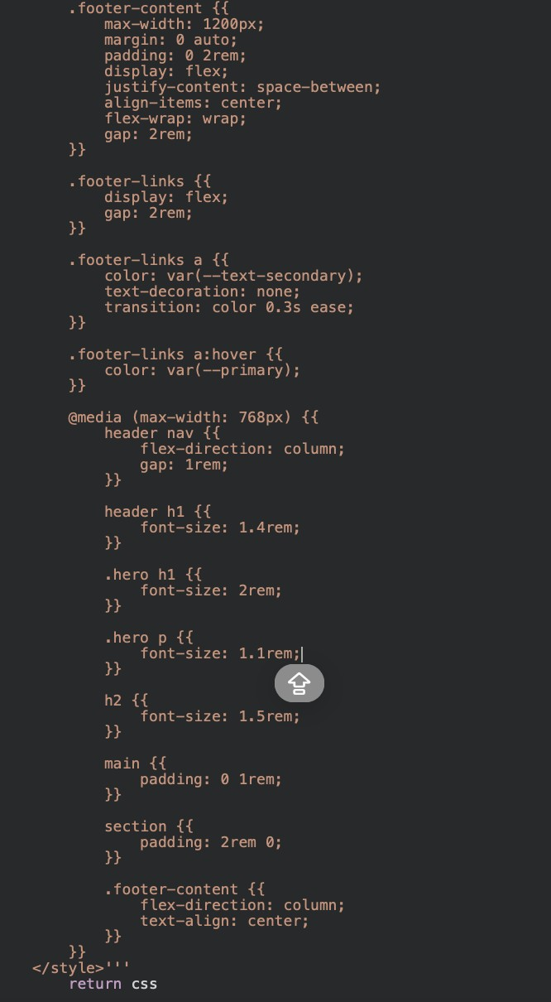
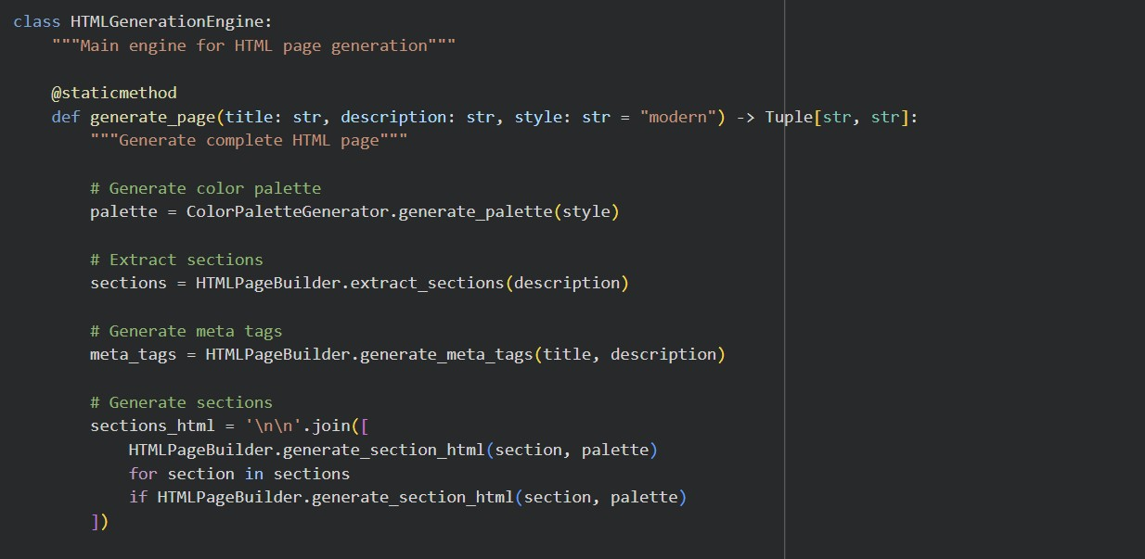

Code reference (hint: click on image and you can copy paste from Comment)
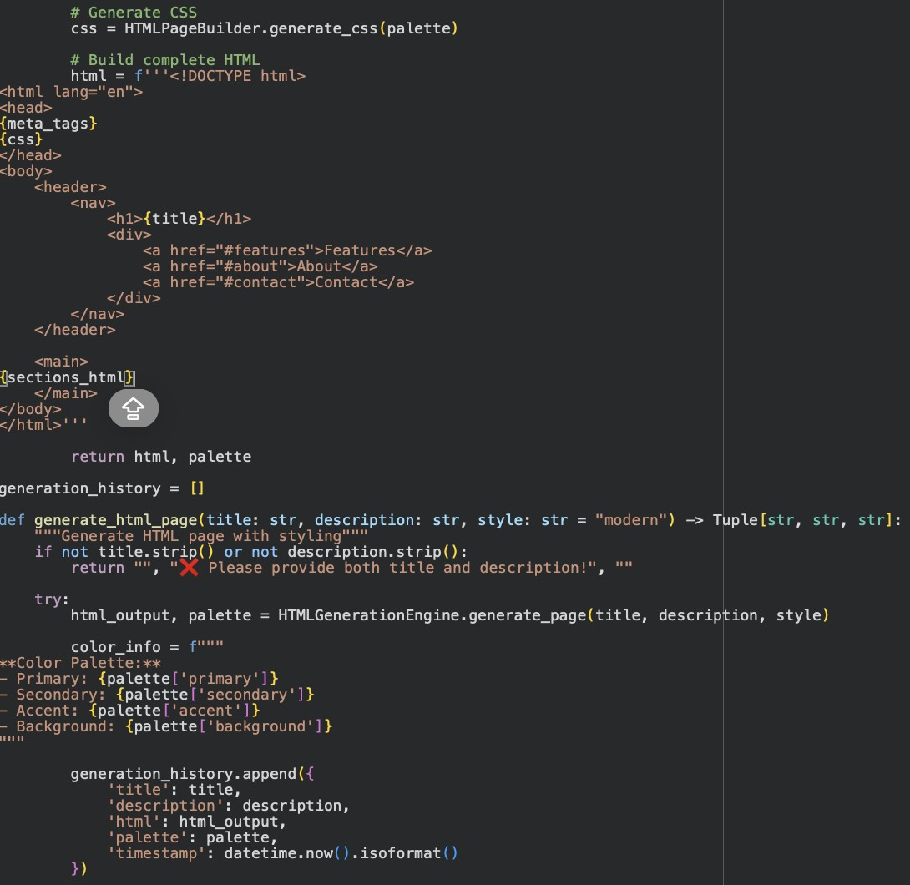
Code reference (hint: click on image and you can copy paste from Comment)
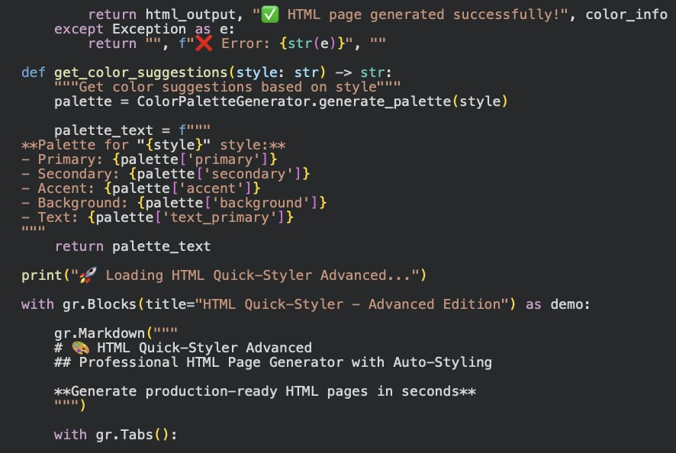
Code reference (hint: click on image and you can copy paste from Comment) Tab 1: Generate Page
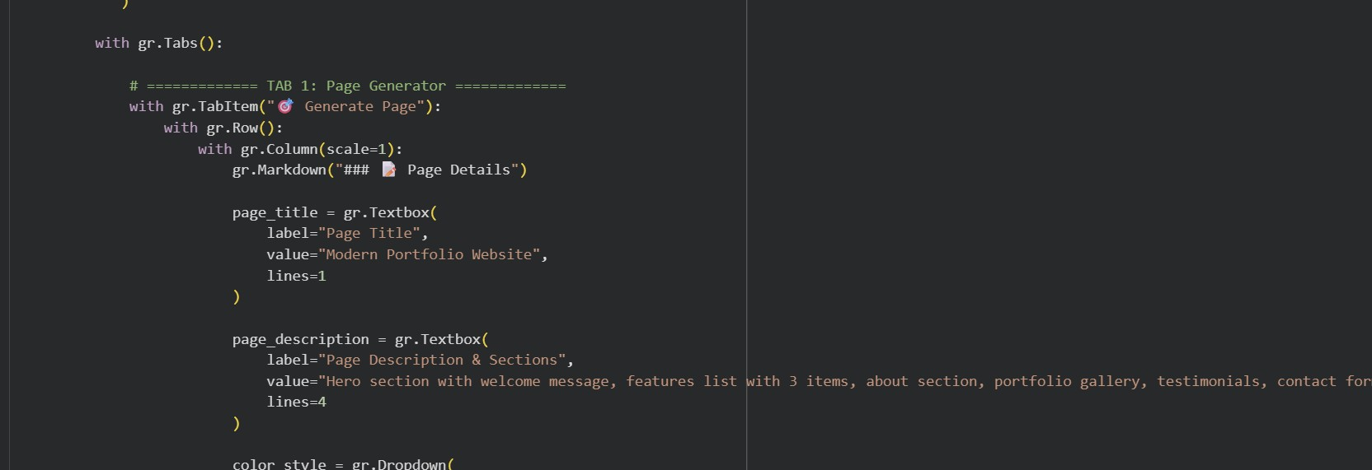
Code reference (hint: click on image and you can copy paste from Comment)
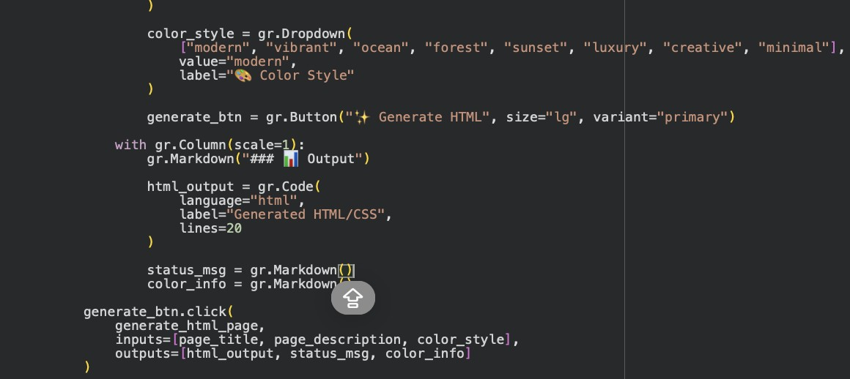

Tab 2: Live Preview
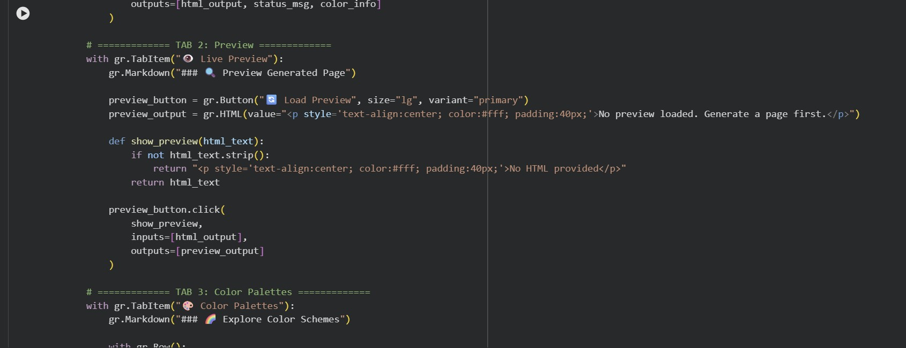
Code reference (hint: click on image and you can copy paste from Comment)

Tab 3: Color Palettes

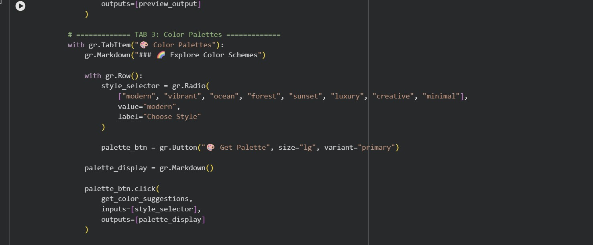
Code reference (hint: click on image and you can copy paste from Comment)

Tab 4: Templates

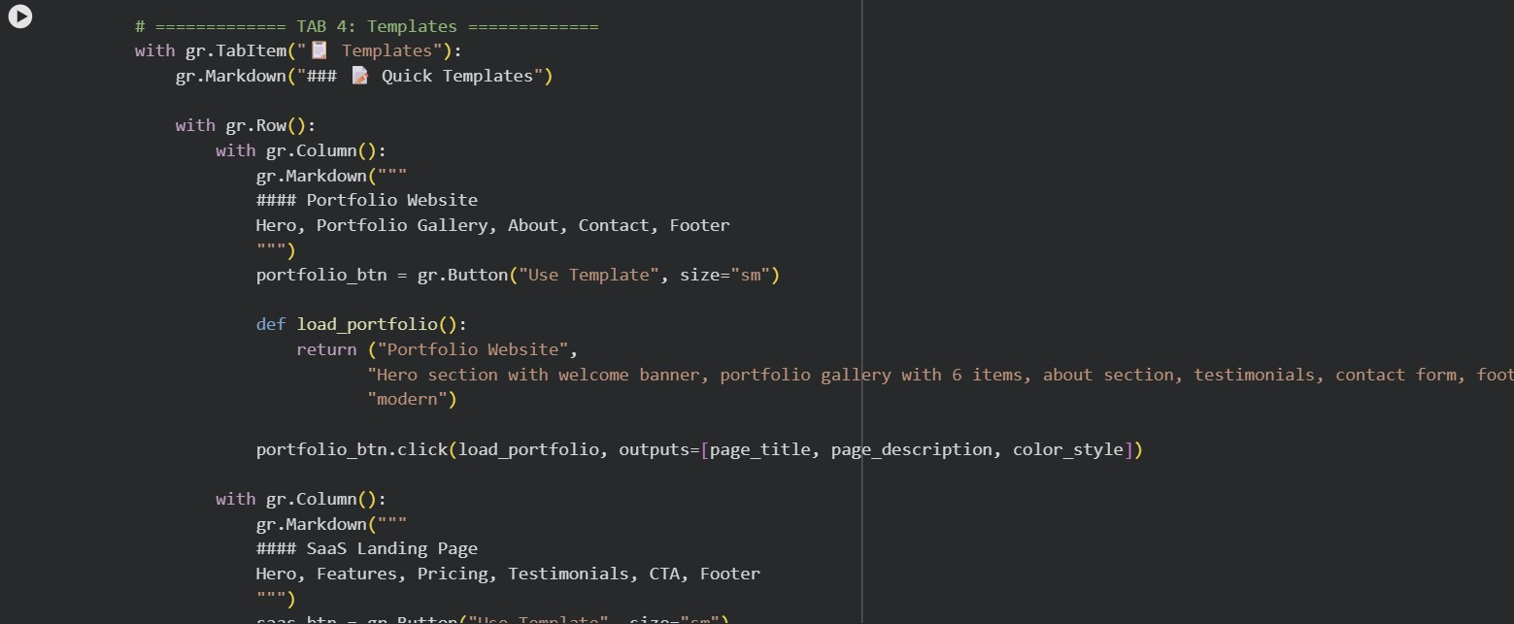
Code reference (hint: click on image and you can copy paste from Comment)
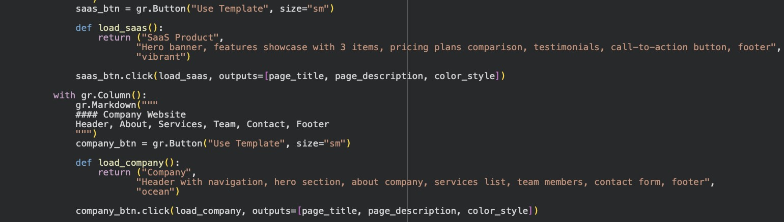
Code reference (hint: click on image and you can copy paste from Comment)

Tab 5: Guide
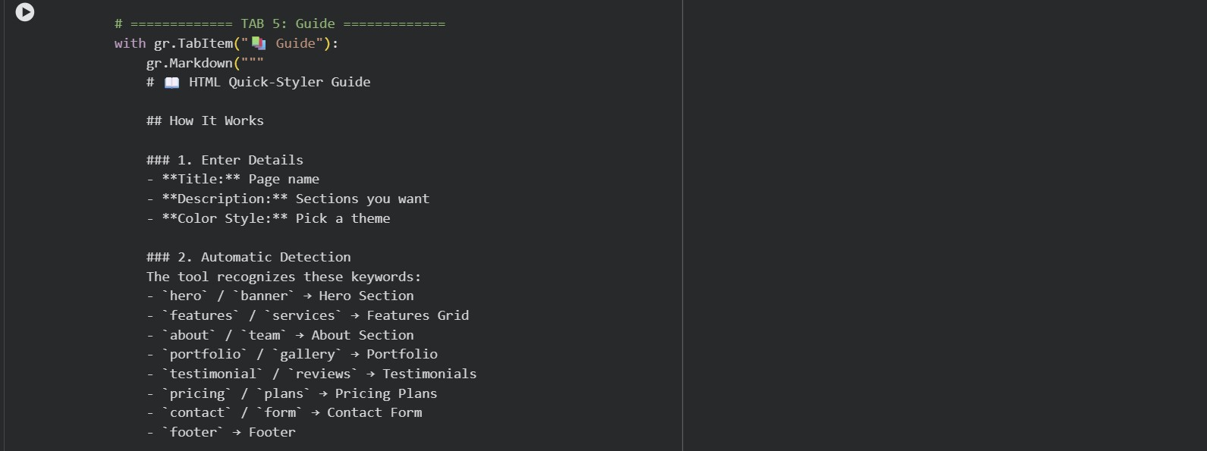
Code reference (hint: click on image and you can copy paste from Comment)

MILESTONE 4: Deployment

Activity 4.1: Google Colab Deployment
Launch the application in Google Colab:

Code reference (hint: click on image and you can copy paste from Comment)

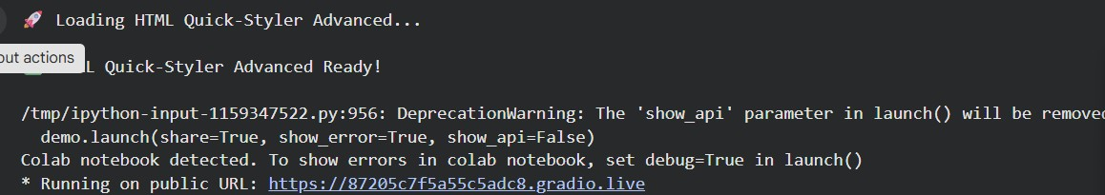
Code reference (hint: click on image and you can copy paste from Comment)

The application will be accessible via:
• Public URL: : https://87205c7f5a55c5adc8.gradio.live
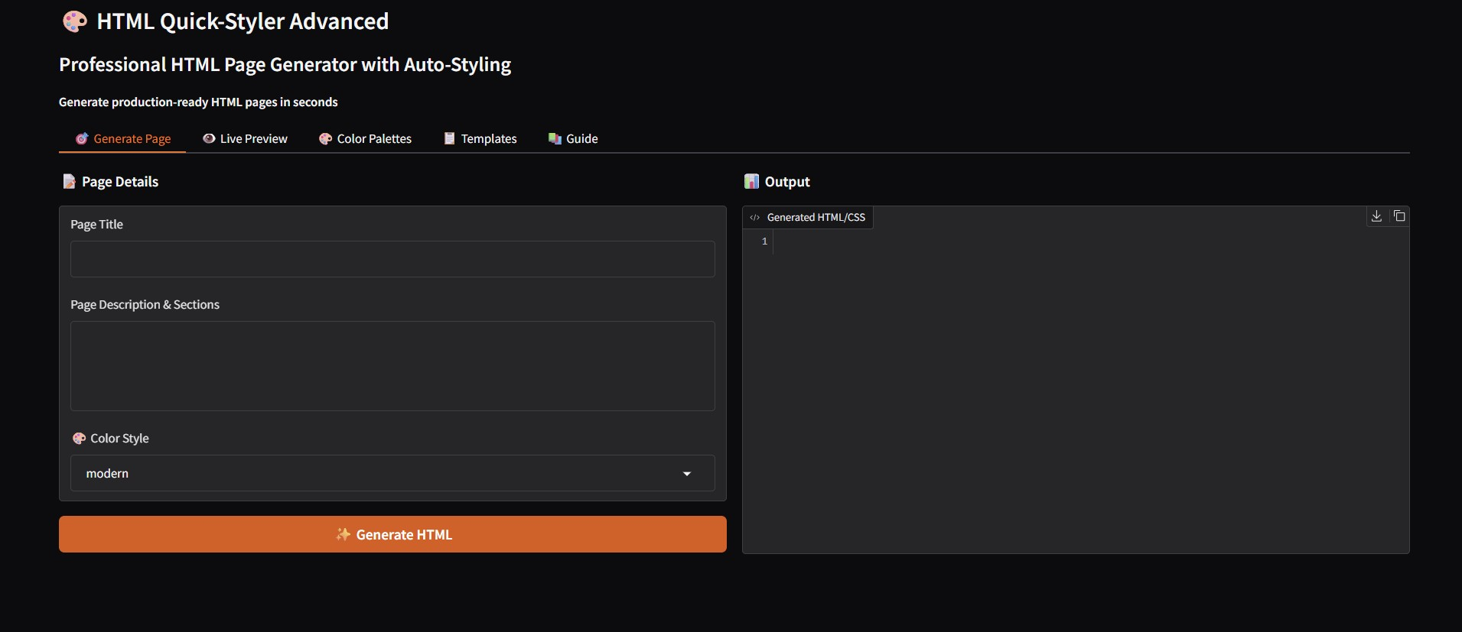

MILESTONE 5: Testing & Validation

Activity 5.1: Functional Testing
Test Case 1: Portfolio Website Generation

Input:
- Title: Modern Portfolio Website
- Description: Hero section with welcome message, features list with 3 items, about section, portfolio gallery, testimonials, contact form, and footer
- Color Style: modern
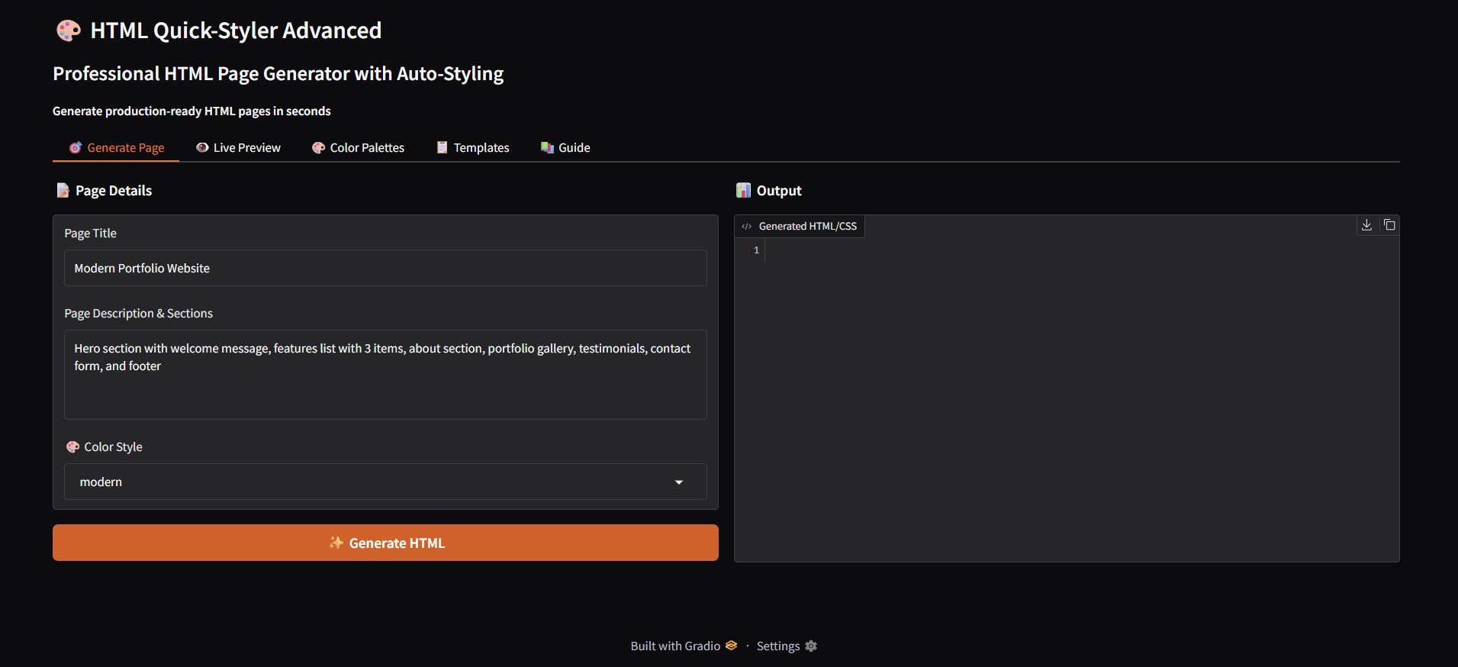
Expected Output:
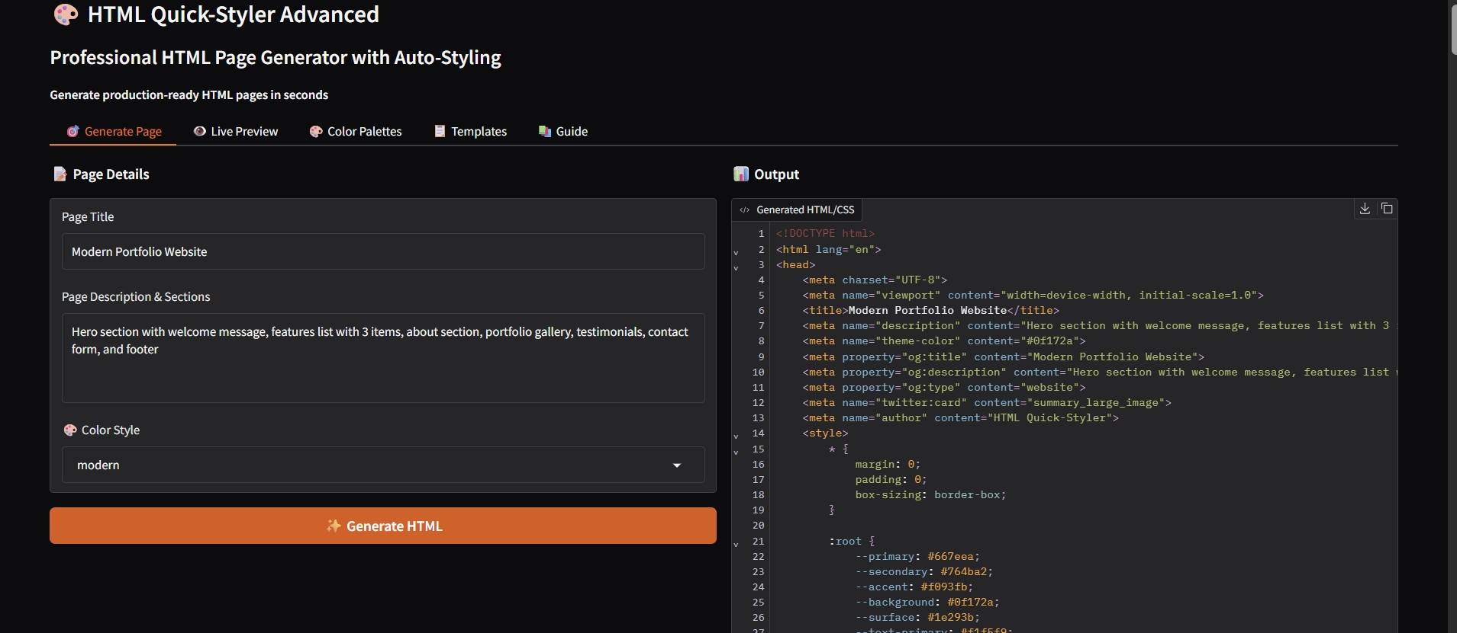

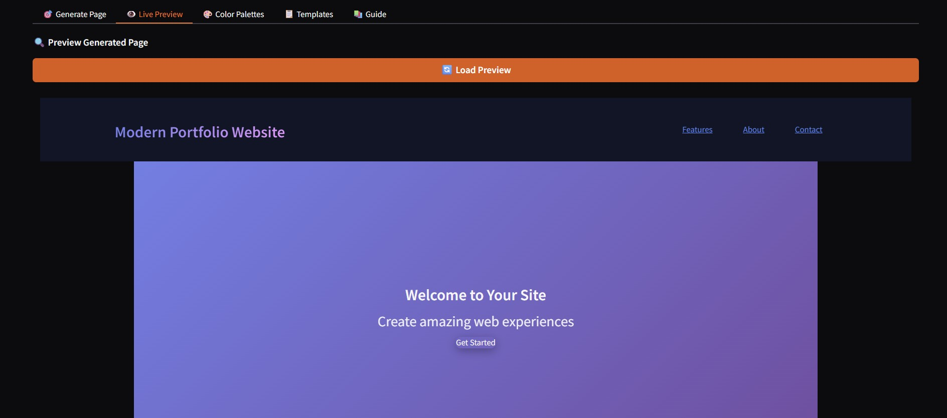
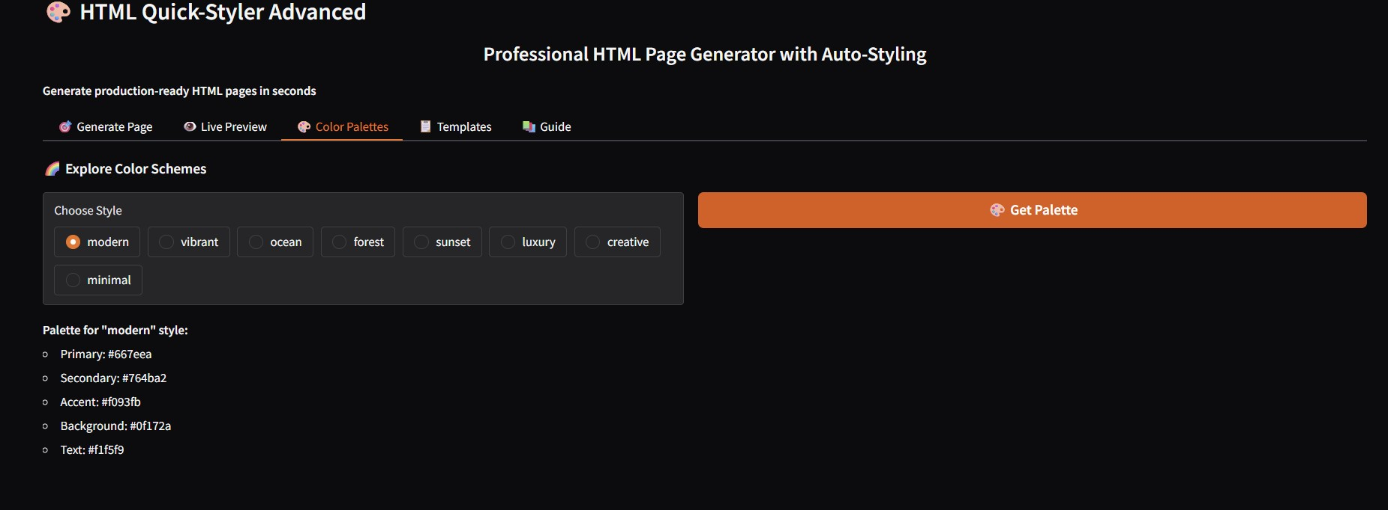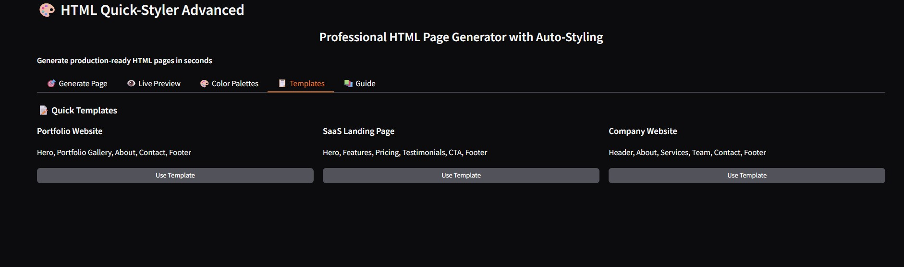
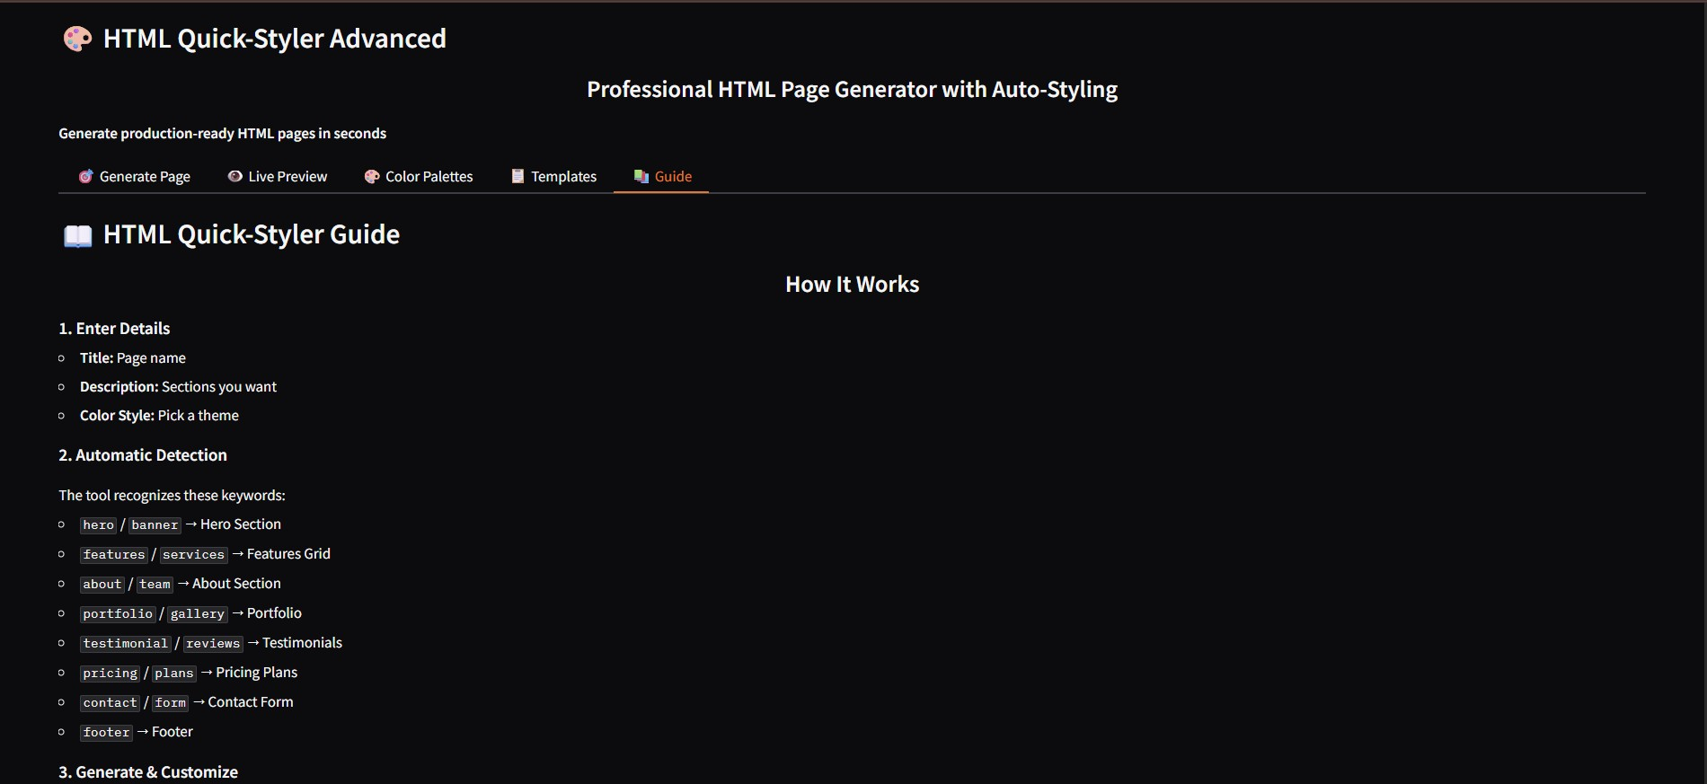

Conclusion
HTML Quick-Styler successfully delivers an intelligent web page generation assistant that combines intuitive design templates with IBM Granite 3.3 2B Instruct model capabilities. By leveraging Gradio's powerful interface framework and Google Colab's cloud infrastructure, the system provides fast, professional, and customizable HTML/CSS generation accessible to designers, developers, and non-technical users alike.

The platform demonstrates the viability of AI-assisted web development, making professional page creation accessible while maintaining high design standards, responsive layouts, and production-ready code quality. With eight distinct color palettes, intelligent section detection, and comprehensive template options, HTML Quick-Styler empowers users to create beautiful websites in minutes rather than hours.

Future enhancements could include custom color picker integration, JavaScript interactivity generation, component library expansion, and integration with popular web frameworks. The modular architecture allows for easy extension and customization to meet evolving user needs and design trends.

